C-40 Burnham Park – The park’s wedged in between the lake and Lakeshore Drive/US 41; to the immediate north are McCormack Place, Burnham Park Harbor, Soldier Field, the Chicago Museum of Natural History, Shedd Aquarium, Adler Planetarium and Northerly Park which occupies the site of the dear, departed Meigs Field (ah, Chicago politics and Hizzoner Jr., Mayor Richard Daley. “National security issues” my ass…). Directly opposite the freeway is a large Illinois Central/Canadian National yard.
L
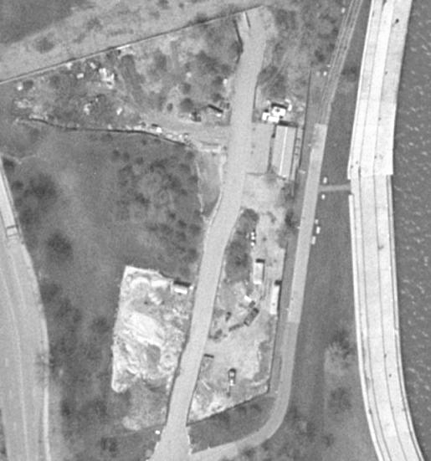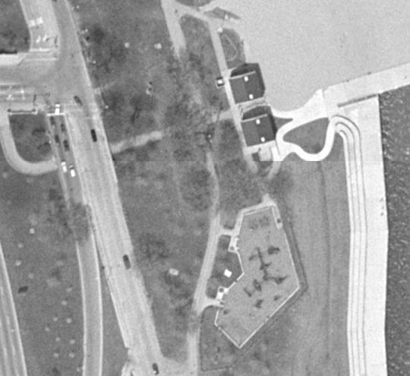
C
Concerning the complex, it was a three-magazine (1B2C)/12-launcher facility with battery at Lake Shore Drive off the end of what’s now I-55 and IFC at Lake Shore and E 31st Street. The operating units were B/485th (/55-9/58) and B/2/57th (9/58-8/63) and yes, putting the missiles in here – above and beyond earlier controversies about armed antiaircraft gun sites – proved entertaining. The Army leased the land in 1953, the local residents protested (gee, no kidding) and E.W. Donahue, Chairman of the Board of Directors of the Hyde Park-Kenwood Community Conference stated:
...
In any event, yes, both components are completely obliterated. You can walk on the former IFC and it’s a nice little park with playground and good view of downtown, Lake Michigan, Navy Pier and the Chicago Harbor Lighthouse. To get to Charlie Four Zero-Lima you have to take Fort Dearborn Road to one of the component facilities of the McCormack Center; I managed to get crossed up once (oh great, some sort of event’s about to kick off), did a couple of 180s, pulled off the road and quickly shot a nice photo of trees, sand, etc, although the aerial photo indicated some presence of pavement and rubble and possibly the outlines of the magazines. From ground level, it didn’t look like even that much remained. Anyway, the IFC’s at 41-50-20N/087-36-24W and the former magazine area’s at 41-50-58N/087-36-38W.

