Story by John Van Gardner

More - http://ed-thelen.org/comp-hist/storiesVanGardner.html

1401 Print Buffer Surgery

The last 1401 bug I remember working on was shortly after I returned from my year in Poughkeepsie, NY on the 360/50. Pat Pattillo had installed the first 360/30 with a 1401 emulator and as soon as it and it’s programs proved out we would begin discontinuing the 1401s.

I received an early wake up call and was told one of the 1401s had been down most of the night and third shift needed assistance. When I arrived I was told they had determined the problem to be in the print buffer in the 01A3 gate but swapping SMS cards did not help.

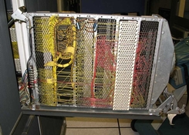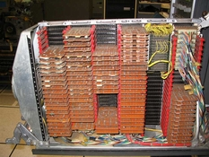
1401 Print Buffer Gate Wiring Side 1401 Print Buffer Gate Card Side

We powered the machine off and removed the SMS cards from the gate and began checking continuity of the drive lines through the array. After about an hour of this we found one that was open.

When we looked in the parts catalog for a part number for the array there was a note that said, “Not field replaceable, use next higher assembly”. The next higher assembly was the whole gate. All the wires to and from the array were soldered on the array end and wire wrapped on the SMS socket end.

By this time the Endicott plant was open and we called them to order a replacement gate. The first thing they wanted to know was what our machine serial number was. It was our oldest machine and was going to be the first one discontinued when the Model 30 was accepted. The plant people told us there was a problem. They only produced gates at the latest Engineering Change Level. They would have to research our EC level and downgrade a new gate to that level. They had no idea how long that was going to take. I left our Field Manager talking to them and went back to see what I could do with the machine.

I knew that all the arrays that I had fixed open wires on in the past, the wire had broken where it was soldered to the frame pin. Using my ohmmeter I found which plane had the open wire. If I could get enough room to unsolder the plane to plane jumper wires I might be able to spread the planes enough to get to the broken wire.

I removed all the cable paddle cards and unsnapped the card guides. The SMS Garvey sockets were held in the gate frame, by extruded “T” shaped aluminum rails between the rows. I removed the screws at the top and bottom of the rails and pulled them up out of the sockets. The only thing holding everything together was, all the wires wrapped to the sockets. By pulling the array towards me the wires bent enough to allow the sockets to fan out. I now had enough room to unsolder one end of the jumper wires on three sides of the array.

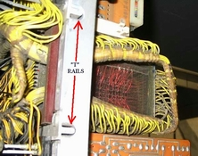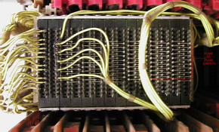
SMS Socket “T” Rails Buffer Array Plane To Plane Jumpers

After separating the jumpers on three sides I removed some of the screws and metal straps that held the array planes together. This gave enough room to separate the planes vertically on the side facing me. I was able to get an inch of clearance and could see the broken wire. It had broken off the frame pin like all the others. I put my six inch scale under the wire end and gently scraped away about 1/32” of the enamel with my x-acto knife. I tined the end of the wire with solder and put a ball of solder on the inside end of the frame pin. Moving the wire end under the solder ball and touching the ball with my iron quickly the ball covered the end of the wire. I made a mental note to not heat the outer end of the frame pin enough to melt the ball on the other end when I replaced the jumper wires.

After a quick check of the repaired plane with my ohmmeter I began reassembly. The screws and straps were installed and the plane jumpers were re-soldered, the “T” rails reinstalled. The card guides were snapped back in place and the cable paddles and SMS cards reinstalled. This went surprising quick. We powered up and ran the 1403 diagnostics with no troubles.

We gave the machine back to the customer and I returned to the CE room to tell the Field manager. He was still on the phone with Endicott trying to resolve getting us a part. Everyone was glad to hear we no longer needed it.

