Story by John Van Gardner
More - http://ed-thelen.org/comp-hist/storiesVanGardner.html

700 Series Goes To Basic

On Friday May 17, 1957 Johnny Malone and Pat Pattillo from the 705 crew and I were told we were being sent to Endicott, NY for basic Customer Engineering school. When we returned Leon Chambers would go to basic. The first day of school was to be May 23, 1957 and we would be there most of the summer. This was before the Interstate Highway System was built so it would take us about two and a half days to drive. That meant we would have to leave on Monday and that left us with the weekend to get ready. It would not be any trouble for Johnny and Pat as they were both single, but I had a wife and a new seven months old baby daughter named Joy. This short notice was the normal thing back then. For some reason you were never told much in advance of plans for you. It took a lot of complaining before this was changed in later years.

My most immediate problem for the weekend was a driveway I was in the middle of paving. I had built my house on a corner lot so I could pave a second driveway from the carport out to the side street. This would let me drive through the carport out to the side street. I had already paved the first section from the carport towards the street but I needed to pour seven more yards of concrete to finish it. The forms were in place and four inches of dirt removed between them. I knew I could not leave it this way until I got back. The forms would be destroyed by the neighborhood kids and the dirt would be full of grass and weeds. I was able to get a Saturday delivery of the concrete and things went good for the first two thirds of the drive but the last section was where the truck had dumped his remaining load in a pile. It had begun to set and it would not flow. All my neighbors saw what was happening and they all chipped in to help even the eighty year old couple behind us. We finally got the hump out but could not finish the surface to where it looked decent. I have always believed the truck had about a half a yard of concrete from the previous job because that was about the amount that started setting immediately.

We had never packed for a trip with a baby before and it was a learning experience. We had a 1953 Ford Tudor and put our clothes in the trunk with the baby stroller on top. Two boxes of stuff were place in the back floorboard and the knocked down baby bed was placed on top of them with the mattress on top. This brought the top level up to just below the seat backs and made a good place for Joy to play and sleep and she could see outside.

We looked at a map, and since we had been up US-29 to Washington and US-1 to New York on our way to Poughkeepsie, we decided to go up US-19 and the Blue Ridge Parkway to see some more of the country. This was a mistake. The Blue Ridge Parkway was a two lane road that rode the crest of the mountains and you could not drive more than 30 mph. Once I got on it and realized the mistake I had to drive 130 miles before I could get off. We gave up on our original plans and took US-11 through Harrisburg, PA to Binghamton, NY. It was a long hard trip but Joy didn’t give us any trouble at all.

IBM had made reservations for us at the Frederick Hotel in Endicott. It was old and the floors in the hall creaked and were up and down but not as bad as the King’s Court in Poughkeepsie. IBM sent a bus to take all the students to the Auditorium at the Country Club where they made our class picture and All the Managers and Instructors were introduced. They each made their welcoming speech and some cards were passed out with their names and home phone numbers. We were told to call these numbers if we had any trouble while we were there. We were given a list of rooms and apartments for rent in the area and told to take the rest of the day off to look for one.
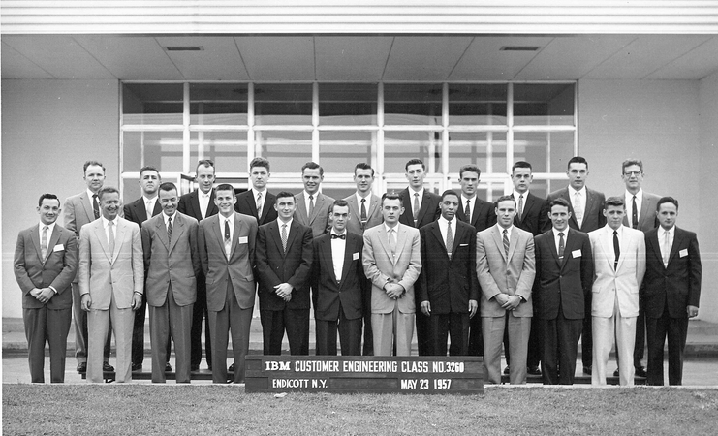

We found a basement apartment in an old three story home on South Street east of downtown Endicott. It had been the original furnace room before the coal fired boiler was removed and a more modern heating system installed. It had just been finished and everything was newly installed and clean. Like every apartment in Endicott the weekly rent was exactly equal to the per diem IBM was paying. Coincidentally the house was owned by a person on Mt. Paran Rd. in Atlanta.
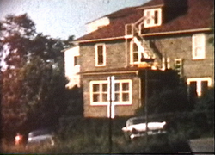
1957 Endicott Basement Apartment

The first day of actual school was held in a room over a store near the east side of the plant. IBM rented space for classrooms all over the Endicott area. They had a caged in room where all the school books and tools were kept. We were each issued the standard set of Customer Engineering tools including a leather grip type bag and a small zipper bag. The instructor told us for the first part of the school we would use the grip bag to carry our books.

The first subject was called “Customer Relations”. It was to teach us how to interact with the customers. It consisted mostly of the Instructor showing us slide shows of Joe CE. He was a cartoon character with vertical rectangular holes for eyes. Joe would get himself into situations and the Instructor would stop the slide show and ask someone in the class how he would handle it.

One day Joe CE had put his screwdriver in his hip pocked and squatted down to work on a machine. Young Jane Customer comes walking by and tears her hose and scratches her leg on Joes’s screwdriver. The Instructor stops the slide projector and ask, “What do you do in a situation like this”?

Do you offer to buy her some new hose?
Do you offer to take her to a Doctor?
Do you offer to rub her leg?
Just what can you say at a time like this?
Then he turns to Johnny Malone and says, “Mr. Malone, “What would you say”?

Johnny’s face lights up with that big grin he always had and said, “Skews Me”. This broke up the class for the rest of the day as that phrase had been the punch line of an ethnic joke of the times. It was the foretelling of things to come.

One morning when Johnny and Pat were coming to work Pat parallel parked his 1955 Ford convertible by the school. He walked to the rear of his car to get their tool bags out of the trunk. He removed his bag and sat it behind himself and as he turned to close the trunk the car parked behind him pulled out and ran over his new tool bag. It busted the whole end out of it and crushed his safety glasses and first aid kit. He took his busted bag over to the place where they were issued and told the Instructor in charge of the crib what had happened. The Instructor went into this long speech about protecting and looking after IBM’s property until Pat had had enough. After all he had just almost been run over. Pat looked at the guy and said, “Look buddy, I didn’t come over here for a ration of crap. I just wanted to get a new bag. Are you going to give me one or not”? He gave Pat a new bag.

Up until this time everyone entering basic school had just come from college. Most of them had never worked at a full time job before and they accepted anything the Instructors told them as gospel. Some of the Instructors had never worked for IBM in the field and were just teaching what they had been told to teach. Now here are three new students that have all worked for other companies before, been in the military for four years and worked for IBM in the most advanced program they had for almost two years.

Most of the machine training was done in West Endicott upstairs over the Fire Station. Here we were to learn to repair the 026 Keypunch, 056 Verifier, 082 Sorter, 519 Reproducing Punch, 077 Collator, 552 Interpreter, and finally the 402 Tabulator. The 026 class was uneventful but the 056 was being taught by one of Instructors that had never been in the field. Somehow the subject of service clearances came up and he made the statement that we would never have to worry about that as IBM put out a specification and the customers had to live by that. The three of us veterans broke out laughing and began telling about all the problems with no service clearances at Lockheed ending up with the story of the Tabulator and Summary Punch in a truck trailer at Flight Test. After that all the other students began asking us what was it really like in the field.

Every Thursday morning all the classes met in a big room with a piano in the Fire House. They passed out the IBM song book and we all sang songs like “Ever Onward” and “Glory To T. J. Watson”. There must have been about ten classes going on at the same time and you could tell who the new guys were. They were the ones standing around looking at everyone else sing. The ones who sang the most and loudest were the classes about to graduate. They had learned that the longer you sang the less time you would spend in class that day. Some one in that class would always yell out “Let’s sing one more song”. There must have been a requirement that to be an Instructor you had to know how to play a piano. There was always one there who could play it.

The bugs they gave us were ridiculously simple. Most of them to do with continuous run circuits. The machine would not keep running or it would not stop running. I shot one bug on the 077 by using just logic and never used my meter. I told the Instructor what relay point I thought was bad by describing the way different operations worked or failed. I told him the normally closed point was not making with the operating point. He became so frustrated he asked me which one was bad. I told him it was probably the one he had stuck the scotch tape on.

They had a lab project for the 077 where they gave you three decks of different color cards and they wanted you to merge the three decks in alternating colors. I got the wiring diagram out and looked to see what impulses I could use to select the cards and when I finished I had nine wires in my board. When I showed it to the Instructor he took it into the other room then he and another instructor came out to watch it run again. It seems the board they had been using for years had 27 wires in it.

One of the 552 bugs was it would not quit running. When I picked up the card weight my finger felt the scotch tape they had put over the recess for the card lever contact. That didn’t take long.

On the July 4th holiday weekend my wife Joyce began having severe abdominal pain. It finally got so bad I took her to the Hospital emergency room. I had been calling every phone number I had but no one was home. I knew that Johnny and Pat were on a trip out of town and all the other people in our apartment house were gone for the weekend. I had to keep Joy in the waiting room at the hospital because they didn’t allow children inside. This meant I could not go with Joyce. I found out later she and the Doctor there were having a terrible time communicating with each other. He was a German Jew with a very heavy accent and she had her normal Gone With the Wind southern accent. She told him her stomach was sore and he thought she said her stomach was sour. He admitted her for observation and there I was in the waiting room with an eight months old baby. I told the nurse at the reception area to tell Joyce I was taking Joy back to the apartment to feed and bath her before bedtime. Somehow we got through those three days until Joyce was released from the hospital. Joy never gave me a bit of trouble but when I went to pick Joyce up when she was released she did because I had put Joy’s pinafore on backwards tying it with the bow in front.

When we got to the 402 class one day two instructors had been working on one of the lab machines all morning for a print problem. It was printing half of one character and half of the one above it on the type bar. Pat Pattillo took a look at it and got a Plews oil can and squirted some # 6 on the sides of the type bar that was failing. After a few lines of print it quit failing. It was very embarrassing for the two Instructors.

One of the lab projects was to remove and install the two speed clutch from a 402. Johnny and Pat were lab partners on one machine and I noticed they had removed the clutch and kept asking this old gray headed Instructor questions about it. The next time I looked over I saw the Instructor laying flat of his back installing the clutch. Those two had coned him into installing the clutch because it was so dirty they didn’t want to do it.

The last class was Basic Electronics. It was held in a rented Quanset hut building that used to be a night club. They used to say this was the only night club IBM students were allowed to go to. It was on North Street just down the side street from my apartment and I could walk to class.

The first day of class Johnny, Pat and I were the first to arrive. The classroom had long tables with a breadboard type electronic chassis in front of each station. Each one had a supply of vacuum tube pluggable units like the ones used in the 650 and 604 machines. I found a couple of inverters and rigged up a multivibrator. There were lots of trigger units so I built a five stage binary counter on my breadboard. Johnny and Pat did the same thing and we cascaded them together into a fifteen stage binary counter. We were sitting there watching the neon lights blink in binary fashion when the Instructor arrived. He said, “All right, Who is the wise guy that did this”? We all confessed and he wanted to know how we knew how to do it. We told him we were 700 series men and he said he had already heard about us. We found out later the last lab project of the class was to build a three stage binary counter.

This was our worst class. We all actually failed our written exam because their answers were wrong. One of the questions we argued the most about was a true false. The question stated that the only way to flip a trigger was with a negative shift input. Their answer was true. That was because the only trigger they had heard of was the kind in the little pluggable units in the class. The 700 series had triggers that had +DC sets, -DC sets, +shift, -shift, -binary and plate pullovers. So their answer was wrong. The Instructor said we were not supposed to know about all those other circuits. I asked him how was I to know what it was that I was not supposed to know.

The final straw came when in our final interview we were told when we were to report to our office. They had told our office we would be there on Monday. This meant to get there our travel days would be over the weekend. We knew they were not going to pay overtime for us to travel and we were not going to travel free on our weekend. I don’t know how many new hire students they talked into this but it didn’t work with us. They agreed to let us take the final quiz a day early and leave early so our travel time would be on weekdays.

When I got home my Manager wanted to know what had gone on in basic. I told him everything I could remember. He said the school had written a letter to the field telling them not to send any more 700 series men to Basic as they were too disruptive to the school. Leon Chambers never had to go to Basic.

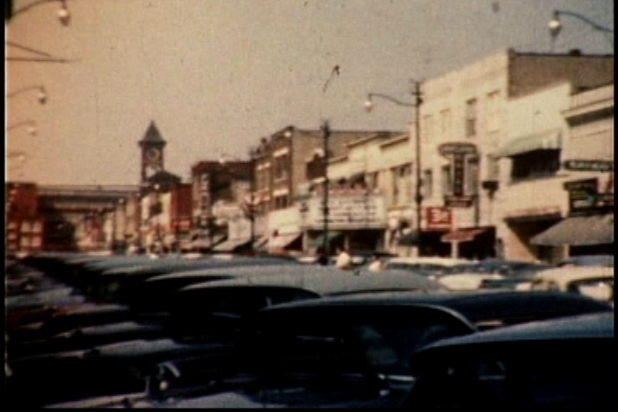
Downtown Endicott 1957
=========================================================================

