Story by John Van Gardner
More - http://ed-thelen.org/comp-hist/storiesVanGardner.html
(updated July 9, 2016)

7094 II

When Lockheed won the contract to build the C-5 in October 1965, they knew they were going to need more computing power. At the time Math Analysis had a 7094 they owned and one they were leasing from Greyhound Leasing. The California division had a directly coupled 7094 II that they were replacing with a 360/75. They decided to bring it to the Georgia Division.

At this time there was no computer room to put it in and we did not have anyone trained on the Mod. II. Lockheed began building a computer room in an old cafeteria down in tunnel 2 of the plant. I ordered a set of manuals for the Mod. II and spent the whole Labor Day weekend reading them.
On Tuesday we found out there were no 7607 data channels coming with the machine as it had been directly coupled to a 7044. IBM found 2 somewhere in a warehouse but they did not have the feature that allowed attachment to a Mod. II. I called Poughkeepsie and had someone read me the wiring list and card list for the change. I recorded the phone conversation on an IBM Executary dictation machine our salesman, Bill Bull, had given me when it broke (just a bad relay).
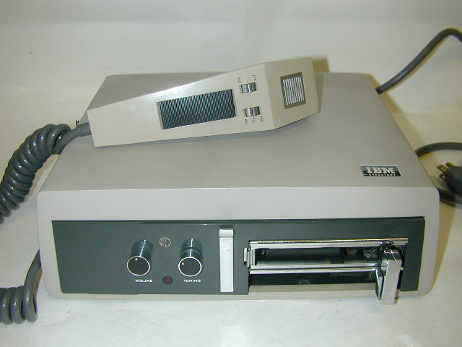
Brian Rowland made great use of this Executary on the night shift by recording such classic things as the proper procedure to remove the covers of an IBM 557 Interpreter. His most successful use of the machine was to record a message, then put the loop tape on backwards and play it memorizing the sounds. He would make a recording saying these sounds ( A-Shore-A-Dad-Gibb) with the tape still backwards. When the tape was returned to the normal forward position and played you could understand the message but not recognize the voice. He used this to leave messages to his field Manager and antagonize him greatly.

Poughkeepsie shipped me the cards by air. Lockheed put the 7094 II and all the tape drives on their
L-100 (Civilian version of the C-130) and flew them to us.
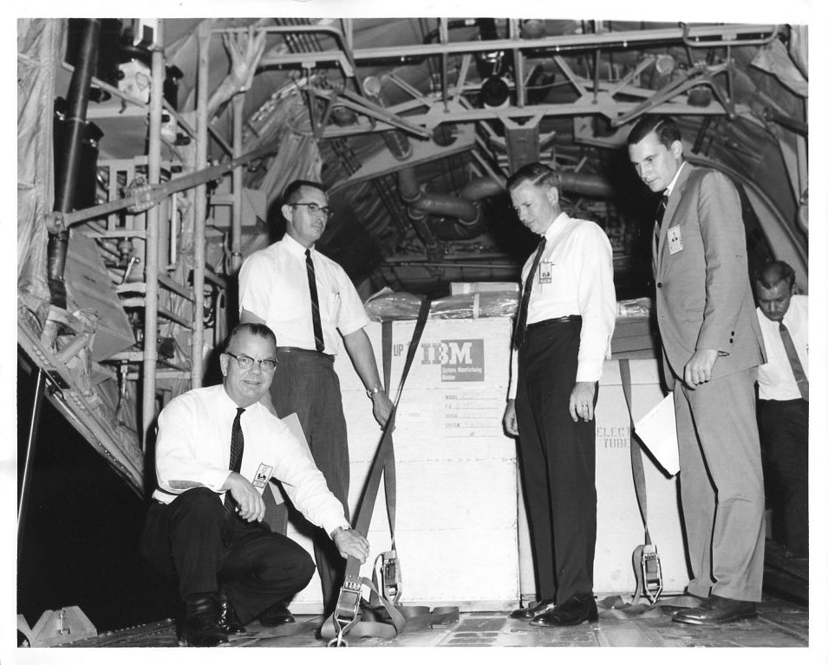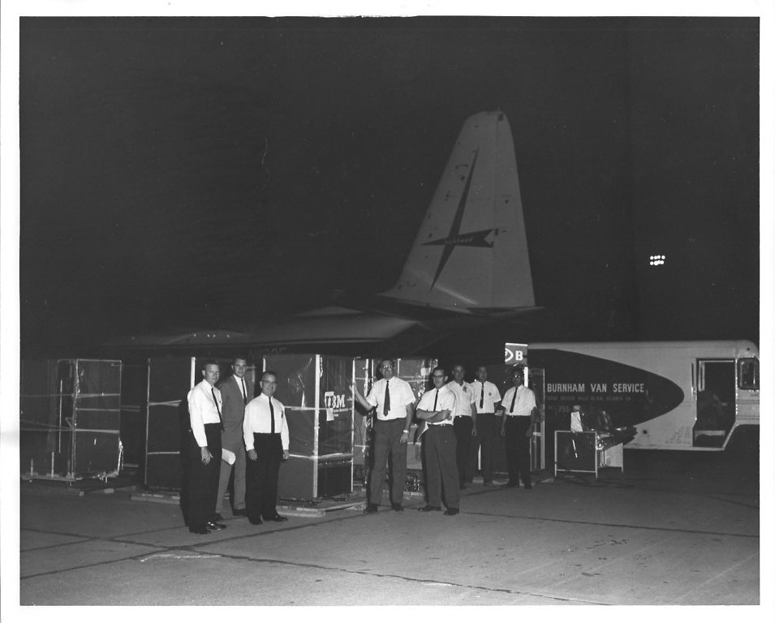
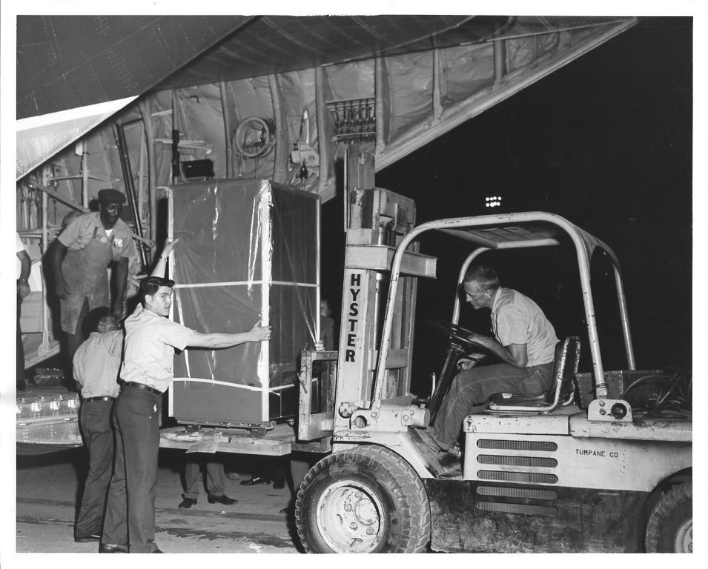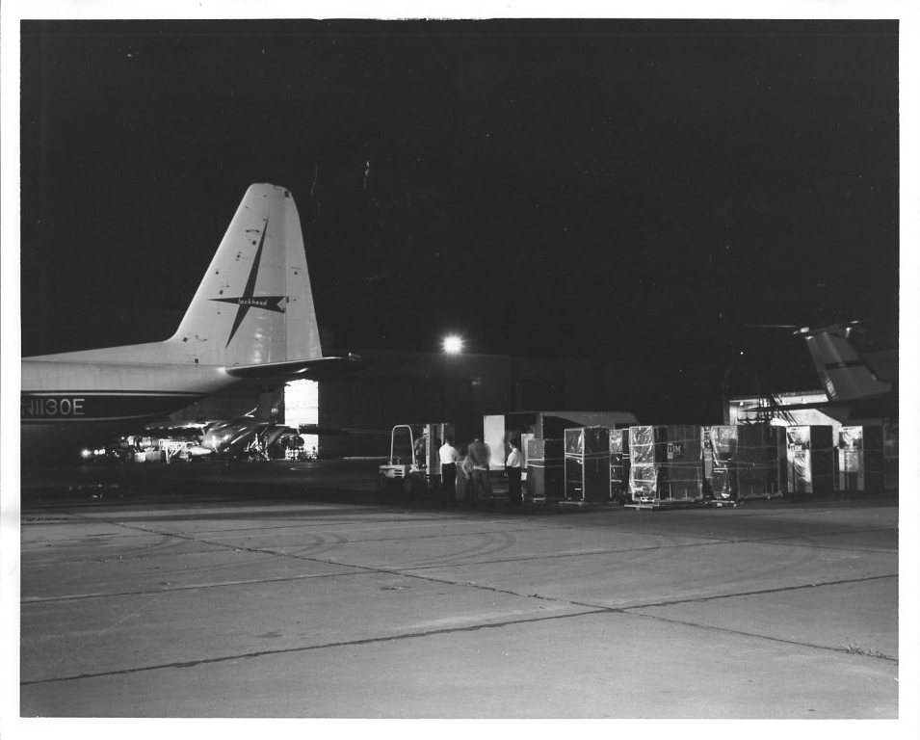
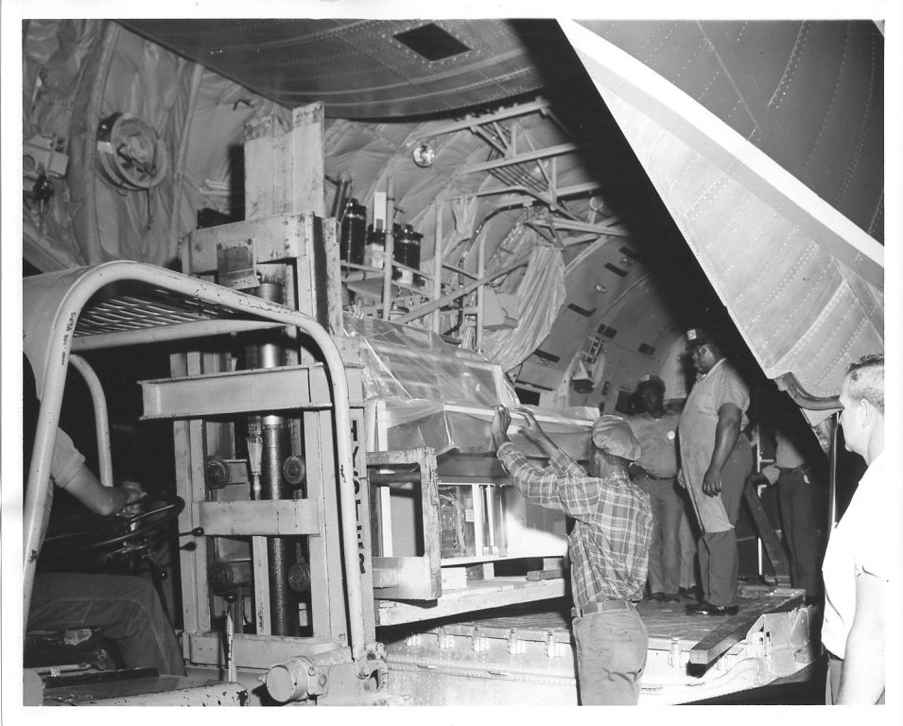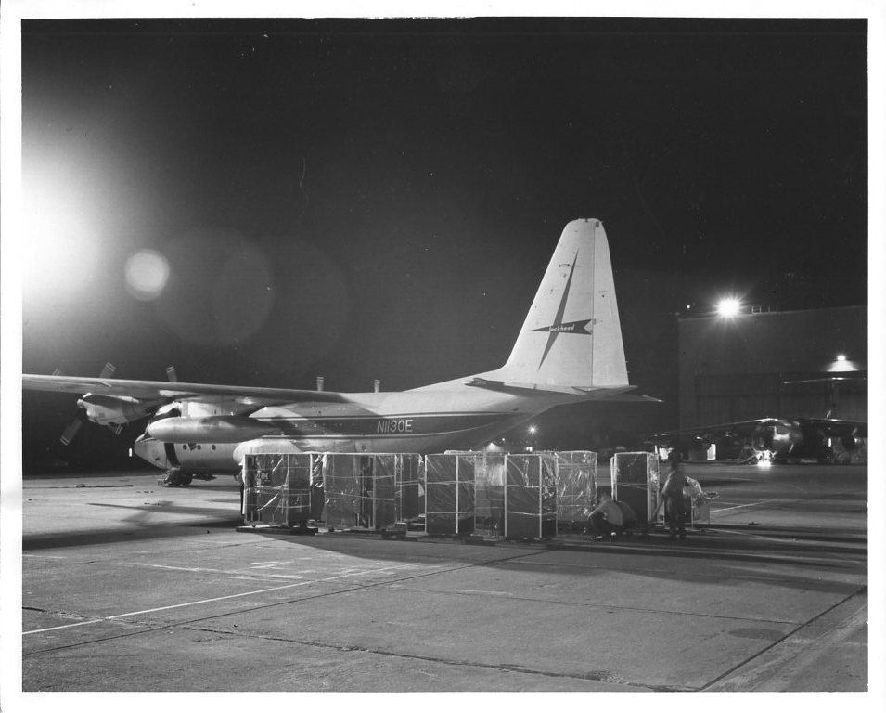

By the time the machine arrived Lockheed had built a small section of the raised floor with a temporary ramp in the middle of the old cafeteria in tunnel 2. We positioned the frames and began wiring the channels. It was freezing cold as none of the equipment was powered up so I worked with my coat on. The painters were painting the ceiling with a roller and when I got home I had paint all up my backside. It ruined a good suit.

After we got all the construction out of the way everything went as a normal installation. I was able to trouble shoot all the bugs we had and from the day Lockheed decided to bring the machine from California to the day we turned it over to them it was 18 days.

I had one interesting bug on this machine about 3 months before it left. They had a program that was a matrix inversion problem. It gave different answers every time they ran it. I found out that if you turned off the overlap switch it would run correctly but slower. Lockheed had a young blond mathematician named Stuart Austin who worked with me on the problem and she found out that one of the instructions in an index loop, that added up a column of numbers, was picking up a bit in the decrement field of the instruction.

The 7094 II used an air cooled split array memory with a cycle time of 1.4 microseconds. I scoped the memory and found that the location of the instruction was being half selected many consecutive cycles during the loop. I talked to Poughkeepsie and they said, that was sometimes caused by a core that had a chip out of it, and it would flip with half current. They said the only way to fix it was to replace the core plane in the array and it would cost $35,000.00 for them to send someone to do it. We knew the machine was due to go out in 3 months and that the program would run if you turned off interleave so I decided to try and fix it. I took a current probe and looked at the current pulse on the half selected drive line and decided to add a resistor in series with the terminator for that line. If I remember correctly I think the terminator was a 250 ohm Non-inductive resistor so I added a 25 ohm in series and looked at the scope. I could not tell the difference in the current pulse. I tried the program and it failed. I had already replaced the 250 ohm resistor just in case so I took the original 250 ohm and added it in series and the current pulse dropped about 10%. The program worked fine. I ran all the diagnostics and bias test and it worked. Well, so much for ohms law. I had forgotten I was trying to send a square wave pulse down a long wire with lots of inductive kickback. The machine ran fine until it left and a 250 ohm resistor saved $35.000.00. Stuart Austin went on to program the computer at the wind tunnel where she met and married Johnny Johnson. They both later went to work for IBM as System Engineers..

