Story by John Van Gardner
More - http://ed-thelen.org/comp-hist/storiesVanGardner.html

A Check for $2,000,000.08 ?

One day I received a message to go to First National Bank in Atlanta and see the System Programmer Dave Turner about a problem with the 155. He has just left Lockheed to go to work for the bank.

He said his new machine was failing on the CVB (Convert to Binary) instruction and he had a three instructions loop that would prove it. I asked him how he found it. He told me that when they ran the program that totals all the checks they were sending to the Federal Reserve Bank it didn’t balance. They ran the program on their 360/50 and it balanced. He had worked several days to come up with the loop. The problem was a check for $2,000,000.08 was not converting to binary to the correct value.

We got the machine and I ran the diagnostics which did not show any trouble. Then I keyed in the loop and it failed. I call the Poughkeepsie plant and explained the situation. After a long pause on the other end they told me it was a known problem and they had a fix for it. They went on to tell me it was a microcode problem with any number that the units position and the millions position added up to 10. If the check had been for $8,000,000.02 cents it would have failed also.

The 155 had its microcode etched into chips on very large cards and the only way to change it was to etch the new code into new chips and manufacture the cards. I was surprised to hear that they had new cards they could send me. They shipped two cards by air and I installed them the next day and fixed the problem.

I asked the programmer who would write a check for $2,000,000.08. It seemed like such an unusual amount. He said it was a U.S. Treasury Department check to E. I. DuPont for managing the Savannah River Project Atomic Energy Plant. (This is where they made the Tritium for nuclear weapons)

I always felt very lucky this trouble didn’t turn into a disaster. First, the Systems Programmer had really nailed down the problem before he turned in a service call. Second, the plant was aware of the problem and had a fix for it. It would have really been different if we had been the first to report the trouble and they had to design a code fix and make the replacement cards.

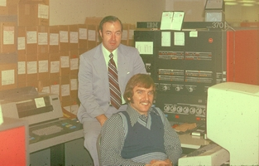
Van & Operator at 3155 Console

=========================================================================

