Story by John Van Gardner
More - http://ed-thelen.org/comp-hist/storiesVanGardner.html

A Battlefield Commission.

The IBM 704 was the first system I worked on after I went to work of them in 1955. It had 5000 vacuum tubes, used 90 KVA of 208 Volts three phase electricity and required 120 tons of air conditioning to cool it.

There were two frames that were nothing but power supplies, one for the positive voltages and one for the negative. It used –30, +15, +220, -100, -130, -250, +150 volts DC. The +220 supply was rated at 16 amps. It had two ELC16J gas Thyratron tubes for rectifiers in a full wave configuration. The whole end of the frame was a bank of electrolytic capacitors in parallel with almost a Farad capacity. I wish I had taken a movie of this power supply with the doors open. It really looked like a scene from a Frankenstein movie. The ELC16J tubes were about a foot tall and gas glowed a blue flickering color. The plate element of the tube would turn cherry red from the heat.

The transformers were huge. They were wound with copper strips about 1/4" X 1/16" instead of wire. Each layer of winding was on top of insulating spacers about 1/8" square. There was an air plenum under them with a squirrel cage blower to cool them.

One day at the Lockheed Plant in Marietta, Ga. there was a loud noise from the computer room that sounded like a 12 gauge shotgun immediately followed by the gong bell that sounded any time the computer shut down. Something had shorted the +220 volt power supply transformer.
Looking down into the transformer you could see a cavity about the size of a tennis ball that was full of balls of copper from BB size to marble size.

None of these transformers had ever failed before and there were none in the parts system. The only way to get one quickly was to remove it from a system on the production line at Poughkeepsie, NY. There was only one system on the line that the transformer could be removed from without delaying shipment to some other customer. The transformer was removed and put in a car and driven to Idlewild Airport in NYC. It was put on a Delta Air Lines Lockheed L-100 (civilian C-130) headed for Atlanta with an intermediate stop a Washington
National Airport.

Something malfunctioned on the airplane and a part had to be replaced before it could take off for Atlanta. This part had to come from Lockheed at Marietta. IBM could not get the part they needed to fix Lockheed's computer because Delta could not get the part from Lockheed to fix the airplane.

To add even more intrigue to the story there was a team of Salesmen from CDC (Control Data Corporation) at Lockheed trying to sell them one of CDC’s new all transistor 1604 computer systems. Needless to say, everyone in IBM was under great pressure to get the 704 back in operation.

I started looking around to see if there was some way to come up with a power supply that could supply 220 volts at 16 amps. The largest spare power supply we had was a 250 volts at 8 amps that was used in the peripheral system control units of the 705 system also at Lockheed. These peripheral systems were all hardware (No program control) machines that did IBM card to magnetic tape, magnetic tape to IBM card and magnetic tape to printer functions. This supply used large selenium rectifiers that were about 8" square. It was adjustable as it used a saturable reactor transformer that had a potentiometer to adjust the current to the control winding.

There were several peripheral systems and I was able to borrow one of the 250 volt supplies from one of them that was shut down. I was able to find a metal cart used to haul IBM card trays in and out of the computer room and with some help put the two supplies side beside on top of the cart. The supplies were so heavy it took two men to pick one up. Lockheed manufactured all the cable harnesses used in the airplanes they were building onsite and it was no trouble to get a roll of wire from them. I wired the two supplies in parallel and the output to the power distribution unit of the 704 system. The voltage adjust pots were set to minimum and the system power was sequenced up manually until the spare supplies came up. The voltage was adjusted slowly upward on each supplied a little at a time. When we reached 220 volts we could tell one supply was getting hotter than the other so I lowered the pot on that supply and raised the other. After about 15 minutes of adjusting the pots back and forth they seemed to be about equal. Both supplies were at their maximum current output and the heat waves coming off the red paint on the seleniums was beginning to look like smoke. We had two Electrolux tubular vacuum cleaners in the shop. These were the kind that you plugged the hose in one end if you wanted to vacuum and the other end if you wanted to blow air. I took the bag out of each vacuum cleaner to increase the air flow and set them on another cart where they could blow directly through the plates on the rectifiers. After about half an hour it seemed stable enough to sequence the system power on up and try it out. We ran the diagnostic programs and turned the system over to the Lockheed operators while the meeting with CDC was still going on.

The IBM sales team had set up a meeting with Lockheed for after lunch to try and counter the CDC sales pitch. The IBM Branch Manager, Herb Harris, and Customer Engineering Manager, Manry Amos, were there as well as the Account Salesman. When the meeting was over all the IBM people came out to see me and said that the end result was Lockheed explained all the virtues of the CDC 1604 and IBM countered by saying "Yes, but will you get service from them like you just got from IBM?".

Lockheed decided to wait for an IBM 7090. The 7090 was the civilian version of the all transistor computer developed for the BMEWS (Ballistic Missile Early Warning System).

As our little meeting broke up Herb Harris turned to Manry Amos and said, "I think this man deserves a raise". When my next pay check came I had a $35.00 a month increase. This was a good increase back in those days especially as I received that extra $35.00 a month for the rest of my 37 year career. I felt like I had just received a battle field commission. I never heard of this happening to anyone else.

When our second shift man came in he wanted to know what the adjustment procedure was for
the power supply and I told him, "Just tune for minimum smoke".

Lockheed finally got the part to their airplane and we received our transformer. The 704 System ran for over two days with the jury rigged power supplies.

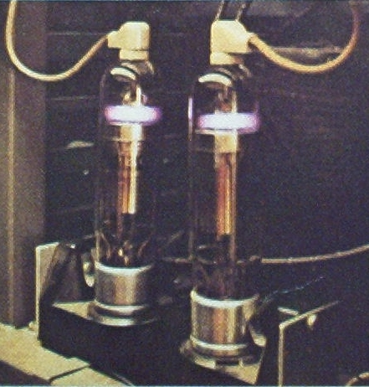
Two of the Gas Thyratron Tubes Used As Rectifiers In The 704 System.

