Story by John Van Gardner
More - http://ed-thelen.org/comp-hist/storiesVanGardner.html

A Flash of Yellow

One day a truck arrived from Endicott with a 2821 Control Unit, 1402-N1 Reader Punch and a 1403 Chain Printer to be tested on the Model 40 and 50. It had already been tested on the Model 30 in Endicott. It was put on the Model 40 and also worked fine but when placed on the Model 50 there was a problem.

If you printed the line:
ABCDEFGHIJKLMNOPQRSTUVWXYZ
What you got was:
ACEGIKMOQSUWY

The problem was that the channel on the 50 was so much faster than the 30 or 40 the 2821 could not keep up and left out every other character. This was a simple bug to trouble shoot as you could place the machine in a loop and scope it. A quick phone call to 2821 Engineering in Endicott resulted in a change to a delay card in the interface circuits. This shows the value of product testing.

The next 2821 trouble was not so easy. When the printer diagnostics were run they printed a full 120 character line of print. The machine printed a page then stopped with a print check. Looking at the last line of print nothing had printed in columns 50 through 59.

Vince Callahan was working on the problem. Vince had been a “Floater” over in the plant for years on the 7090/7094 production line. Floater was the name they hung on the guy that floated from test cell to test cell fixing all the hard bugs. He had even been to Lockheed and worked with me on some conversions. He has never worked on I/O machines in the plant but when he transferred to Engineering they gave him the job of maintaining the I/O on the Model 50. He knew that I was the 1403 Specialist for the southeast so he came got me for help.

To keep from tying up the Model 50 working on the 1403 I connected the I/O tester box to the 2821 and tried to print a line of H characters. Column 50 through 59 would not print even though they had printed on the first page Vince had tried.

Using my 1401 experience I pulled the hammer driver card for position 50 and check to see if the fuse was blown. It was blown. Checking further I found the fuses for position 50-59 were all blown.

When I asked some of the Engineers if they had any fuses for the hammer driver cards they got all excited. They made a lot of disparaging remarks about the stupid Endicott Engineers that put fuses on transistor cards.

I told them I didn’t think it was so stupid because the Poughkeepsie Engineers had done the same thing on the switch core drivers for the 7302 memory used on the Stretch machine. The Stretch machine was their pride and glory. They didn’t believe me until Vince verified the 7302, also used on the 7090/7094 did use fuses. Vince volunteered to go over to the plant and see if they had any of the fuses in card repair. I told him to bring a lot of them if he could.

When Vince returned he had a whole box of fuses. I had removed all the hammer driver cards with the blown fuses. The 2821 used a double SMS card with 4 hammer drivers on each card. The 1401 had used a single SMS card that had 2 hammer drivers. We replaced the blown fuses and I put one of the cards back in the machine to try. I did not want to replace all of them until we saw whether the fuses would blow again.

We started the printer and it printed one page with position 50-53 printing ok. Then it quit printing in 50-53. I checked the four fuses and they were blown. I knew we would have to find out what the cause was before replacing any more fuses.

I turned off the check stop switch on the I/O tester so the printer would keep on printing even though it knew there was a problem. This was so I could scope the inputs to hammer driver 50. The 1403 had a scan counter that selected the hammer drivers at the proper time and a hammer fire pulse to fire the driver if you wanted to print in that position. There was a gate line from the scan counter to all the hammer drivers 50-59 called T50. When I scoped this line I saw a normal 5 millisecond pulse for most of the page but once a page I would see a faint trace of a pulse that was 50 millisecond in duration. This was what was probably blowing the fuses. They were 1 amp fuses and the driver was putting 5 amps through them but only for 5 millisecond. This duty cycle was not enough to blow them but 50 milliseconds would.

I scoped the inputs to the circuit that generated the T50 signal but there was nothing there to cause a 50 millisecond output. Fortunately the 2821 had been installed right next to the 1403 and as I watched the scope connected to the 2821 I caught the glint of a yellow flash in my peripheral vision occurring at the same rate as the faint 50 millisecond pulse on the scope. They did not occur at the same time but were at the same rate. When I looked to see what the yellow flash was I saw that it was the yellow glue used to connect the ends of the carriage tape.

The 1403 printer used a punched paper tape to control the forms carriage. It was a 12 channel tape that spaced one space for each line printed. When a customer used a preprinted form he punched a carriage tape the same length to tell the printer where the beginning of the form was and when to skip to the next form. The remaining channels allowed the printer to skip to different parts of the form.

I wondered if the carriage tape circuitry might have something to do with the long T50 pulse. When I placed a blank IBM card under the carriage brushes the long T50 quit occurring. I pulled the IBM card sideways uncovering one channel at a time and when I uncovered the #2 channel the bad T50 returned. There were two brushes for each channel a slow brush and a stop brush. Removing the IBM card so the bad T50 would return, I removed the wire from the #2 slow brush and proved it to be the culprit. I turned the power off and used an ohmmeter to check for any resistance between the T50 line and the #2 slow brush wire. There was as 0 ohm short. Tracing the wires we found a cold flow short where the #2 slow brush wire was wrapped too tightly around one of the T50 pins. Re-routing the wire fixed the problem. After this Engineering requested that I work overtime with them on weekends when they had some special problem they wanted to look into. They contacted my branch office and they said it was ok with them if it was ok with me and Engineering was going to pay for it. They were glad to pay for it because they were having a hard time keeping up with all the troubles they were having. I learned a lot working with the Engineers on weekends.

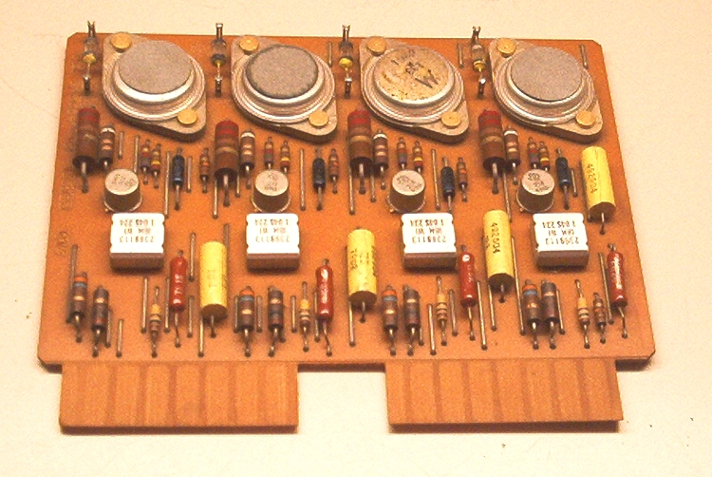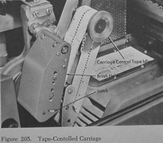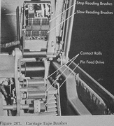
Hammer Driver Card Tape Controlled Carriage Carriage Tape Brushes
=========================================================================

