Story by John Van Gardner
More - http://ed-thelen.org/comp-hist/storiesVanGardner.html

A Pox On Me.

1961 January 12. Jack Bellinger and I started 7090 school in Poughkeepsie, NY. The 7090 was an all transistor version of the 709. This was the last 7090 class we could get into and get out in time to install Lockheed’s machine. When the class was over Jack went home, but It was arranged for me to go over to the plant and work on Lockheed’s machine, in the final test area, until it was ready to ship. I would then go home to help install it.

Things went as planned and I arrived home ready to install the 7090. We were going to have to install it in a small room between the 704 room and the 705 room. It was really too small for the 7090 system but we had to get it installed so Lockheed could make sure all their 704 programs would run on it before we took the 704 out. We would then move the 7090 into the old 704 room which was twice as big.

When we positioned all the units in the room we really needed some more room. I mounted the two 7617 Data Channel Consoles on top of the 7151 console as a temporary solution. The operators found out they could rewind, backspace, forward or backspace file from the console without walking over to the 729 Tape Drives and wanted to make console arrangement permanent. Lockheed had their sheet metal workers make a cover for the back that looked just like the IBM covers. (Lockheed took a picture of the modified console and put it in their recruiting brochure. They had more inquires wanting to know what kind of computer they had than any other subject).

7090 Photo From Recruiting brochure.

After all the frames were in position Jack and I spent several days running all the under floor cables. The 7090 system had a lot of multi-coax cables connecting the frames. The last day we ran cables I began to feel sick but stayed on till we finished all the cables. We were ready to start debugging the system early the next day. That night I got to feeling worse and running a high fever. I went to the doctor and he told me I had Chicken Pox. My two children, Joy and Jeff, had Chicken Pox a couple of weeks before.

I went home and called my Manager and told him. He contacted Lockheed and they told him I could not come in the plant as I had a communicable disease. Gene Satterfield was sent from Redstone Arsenal in Huntsville, Alabama to help Jack debug the machine.

I was really sick for two days with a high fever and chills. The chills were so bad I would shake all over. The only way I could stop shaking was to put Joyce’s portable hair drier under the covers and turn it on high. After my fever broke I felt ok. Jack and Gene had removed all the bugs except one. They were having trouble with the 7302 Core Storage. They had worked on the bug for a couple of days but had not made any headway. I had been talking with them on the telephone several time a day. Since I was feeling ok and didn’t have a fever I told them to go home and I would come in on second shift and see if I could fix it. I reviewed all the information in the log book as to what they had done and decided to start from the beginning.

After about three hours of scooping I found a bad pulse coming out of one of the address decode cards. This was causing some extra switch core drivers to fire and wipe out some data in memory. When I removed the card to swap it I got a real surprise. On the back of the card written in red magic marker was the words “Bad Card’. I knew I had found the bug. This looked like one of the cards they used in school to put bugs on the machine. That was the last bug on the machine so I went home.

(We never found out how or when that card got put in our machine. It failed on the memory diagnostics and I had seen them run at the plant before the machine shipped. We reported it to Poughkeepsie and sent the card to them. If they ever found out how it happened they didn’t tell us.)

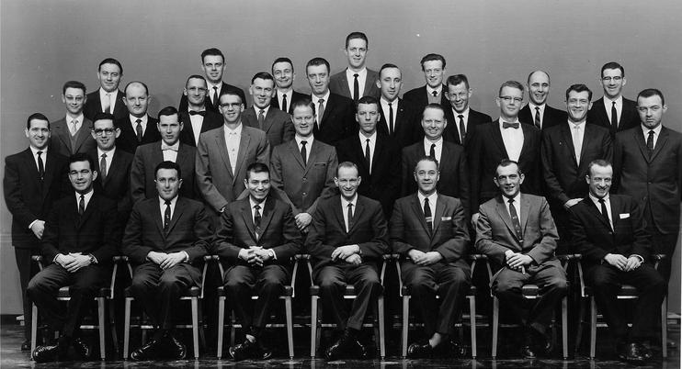
DP CUSTOMER ENGINEERING CLASS #2508 – 7090 FOR 704/709 CUSTOMER ENGINEERS
IBM POUGHKEEPSIE, N. Y. JANUARY 12, 1961
JACK BELLINGER 3RD FROM RIGHT END OF THE SECOND ROW (WEARING BOW TIE).
VAN GARDNER IS ON RIGHT END OF SECOND ROW.

