Story by John Van Gardner
More - http://ed-thelen.org/comp-hist/storiesVanGardner.html

Capt. Eddie’s Friend

February 1961. The Miami office made a request for assistance on the 7090 at Pratt and Whitney in West Palm Beach, Florida. I said I would go but there was only one problem. National Airlines and Eastern Airlines were the two carriers from Atlanta to Miami and National was on strike. Eastern was booked solid on every flight for several days.

Joe Sparks, the Atlanta Customer Engineering Manager, telephoned Captain Eddie Rickenbacker the WWI Ace, who was the CEO of Eastern Airlines, and explained the situation to him. Capt. Eddie was very helpful and told Joe to send me to the airport and they would get me on the next flight.

When I arrived at the ticket counter and told the agent my name he said, “Oh yes Mr. Gardner, here is your ticked.” It was already filled out, something unusual at that time. As I turned to leave the counter I overheard one of the female agents tell one of the stewardess, “I don’t know who that man is but the CEO called and told us to put him on the airplane.

When I got to the airplane it was a Lockheed Electra. I presented my ticked and was escorted to the very back of the airplane. Eastern Electra’s had a curved lounge at the back and this was where the Stewardess sat during takeoff and landings. They offered me my choice of seats and then three of them buckled up and we took off. When we reached cruising altitude the three Stewardesses began serving all the passengers. One of them returned to me immediately with a bottle of champagne wanting to know if I wanted any. I declined as I don’t drink and I was on my way to work on a computer. Just before lunch I was asked what I would like to have to eat. I told her anything but chicken and received a filet mignon. One of the Stewardess stayed with me talking most of the trip. I never had service like that before or since on an airplane. I never told them I was just a traveling flunky going to fix a broke computer. I just let them keep on thinking I was a friend of the CEO of their airline.

(I would like to point out here how different airline travel was back then. It was mostly business travelers and people with a good bit of money. Everyone dressed like they were going to church and you never had to sit next to someone in a tank top wearing flip flops. The original Stewardesses were Nurses to make the passengers feel safe. That evolved into hiring the best looking ones they could find. I always thought Eastern did the best job of that. That was strange as I had heard Capt. Eddie didn’t want to hire women because as soon as they were trained they got married and quit. Delta Airlines recognized that and started not hiring the really good-looking ones. They had a weight limit, to save fuel and that was it.)

(I took another assist trip to Miami to work on a machine at an account close to the airport. There was a motel named Sky Ways, on one side of the airport, and another named Air Ways on the other side. Somehow I went to the wrong one and checked in. The desk clerk did not mention that he did not have a reservation for me. I got up the next morning and went to the dining room to eat and wait for the local Field Manager to come pick me up. I was the first one in the dining room and as I sat there eating all these young women began coming in and sitting four to a table.
After a while the place was full and I was the only male there. About the time I finished eating a young man came in wearing a TWA Stewards uniform. He spoke to some of the girls and they all got up and left with him. I found out from the waitress that the motel was where all the TWA Stewardess trainees stayed while going to school. I called the office to see where the Field Manager was and learned I was at the wrong motel. He came got me and I checked out and we went to the other motel to check in so I could be close to the account.)

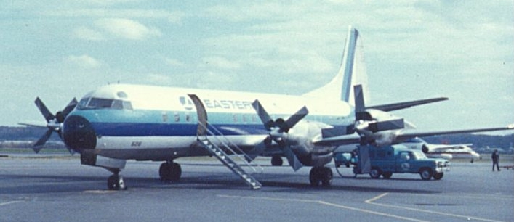
Eastern Airlines Lockheed L-188 Electra

