Story by John Van Gardner
More - http://ed-thelen.org/comp-hist/storiesVanGardner.html

Encounter With Two Movie Stars

In 1957 Twentieth Century Fox made a movie named “Desk Set” staring Spencer Tracy and Katharine Hepburn.

Plot Outline: Two extremely strong personalities clash over the computerization of a TV network's research department.

Fox rented two 727 Tape Drive units from IBM ($550 a month each) to use in their representation of a computer. When they were through making the movie they returned the machines to IBM. At that time Lockheed had a request to IBM for delivery of additional 727s with expedited delivery. IBM did what they called a field transfer and sent the machines directly to Lockheed. When the machines arrived one was assigned to the 704 System and the other to the 705 System. The machines were a wreck. I had the job of getting the one for the 704 ready and Pat Pattillo drew the one for the 705.

The front door of a 727 was made out of brushed stainless steel. Apparently this had caused too much reflection in the movie process so they painted all the stainless steel with some kind of milky lacquer. I thought I would never get it all off.

There was a panel in the middle of the front door that contained the select switch. On the back side of this panel there was a fluorescent light to illuminate the area of the reels and vacuum columns. This must have caused Fox a problem because they had ripped the wires out of the fixture.

Fox could load a tape on the drive but since they didn’t really have a computer they didn’t have any way to make the tape and reels move. They wanted action. There was a motor that turned the reels and drove a friction clutch to lower the read/write head onto the tape when you pressed the load rewind button. Normally this motor only drove the reels a few seconds to dump enough tape in the vacuum columns to operate a switch then it stopped. Fox found out they could put two empty reels on the drive and press load rewind and the reels would keep turning waiting for the non-existent tape to enter the vacuum columns. The reels would continue to turn until you pressed the unload button. This solved Fox’s problem but it ruined the friction clutch that drove the read/write head down on the tape. Once the head was down the clutch had to slip until the unload button was pressed. The lining was worn completely off the clutch on both drives.

Pat and I finally got the drives good enough to put on the systems. At that time the 704 tape drives had decals to identify each as A, B, C, D, etc. We made up a big red star to put on the drive from Fox. This proved to be very prophetic as that drive was always more temperamental than any of the others.

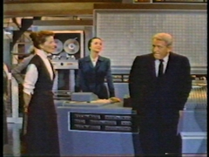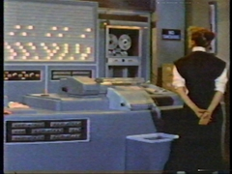

I see the movie Desk Set about twice a year on TV. It always brings memories. We always said we wished Fox had sent us Betty Grable instead of those tape drives.

