Story by John Van Gardner
More - http://ed-thelen.org/comp-hist/storiesVanGardner.html

MADAR

Some of the most expensive parts of an airplane are the engines. On modern jet aircraft these engines cost in the millions of dollars. Occasionally one of the engines would explode and destroy itself and sometimes the airplane. Engineers have said for a long time that if they could closely monitor certain points in an engine they could predict this failure before it happened. If they could save one engine that amount of money would buy a lot of monitoring equipment.

When design started on the C-5 Lockheed decided to include a system which they called MADAR. This was an acronym that stood for Malfunction Analysis Detection And Recording. This system would monitor over 800 test points on the aircraft mostly on the engines.

This system would consist of the sensors and a computer system that would monitor the sensors and output the data to a magnetic tape that could be read by an IBM 729 tape drive. Every air base that stationed C-5s would have a system that could read these tapes and transmit the data to an IBM 360/65 system at Tinker Air Force Base in Oklahoma City, Oklahoma.

IBM had bid their 1100 System for the remote sites and Univac bid their 9200 System. The 9200 was Univac’s attempt at a copy of IBM’s System 360. During the time Lockheed was evaluating the two systems our Salesman came to me for some help. He said the decision had got down to two differences between the machines. One was the 9200 had a much faster cycle time than the 1100 and the other was the 9200 had a Translate instruction and the 1100 did not. I asked for a set of manuals for each machine and these were provided.

Over the weekend I read both programming manuals and the first thing I noticed was the very large number of cycles the Translate instruction required on the 9200. We had always done translations with subroutines on the 704 and 7090. When I read the 1100 manual I realized it was like a baby 7090. I wrote a translate subroutine for the 1100 and added up all the cycles for all the instruction and found out it was actually faster than the 9200.

Monday morning I met with sales and told them what I had done and gave them the subroutine listing. They took it to the Lockheed people doing the evaluation. They assigned Charlene Lampkin (The former Charlene Smith who wrote the square root subroutine for the 704) to evaluate the subroutine. She told them it would work and would be faster than the 9200 Translate instruction. When the final decision was made the 1100 won the competition. This may be the first time a RISC (Reduced Instruction Set Computer) with a faster cycle time beat out a competing machine with a much more complex instruction set.

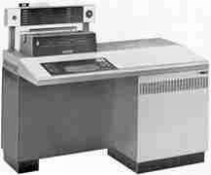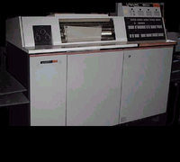

IBM 1130 UNIVAC 9200
=========================================================================

