Story by John Van Gardner
More - http://ed-thelen.org/comp-hist/storiesVanGardner.html

Music To My Ears.

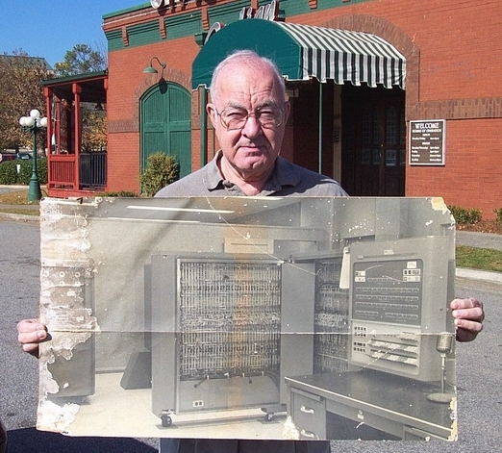
Old poster of 704 at Lockheed Aircraft Marietta, Georgia

One thing in the photo that brings back memories is the microphone on the desk. It was connected to a PA system used to call programmers to the computer when there was a problem with their program. I had gotten interested in audio amplifiers when I built a high fidelity system in the navy. During my school on the 704 as I learned how to program it I got an idea about how to use it as a square wave generator. The 704 had four indicator lights on the console that could be turned on and off with program sense instructions. They were used to give a visual indication of the progress of the program. I keyed in a program using index instructions to turn sense light 1 on and off at different frequencies. I connected the output of the sense light to the microphone input of the PA system. The PA amplifier could not reproduce a square wave so the sound that came out sounded like a clean sign wave.

Some time later my daughter Joy received a toy xylophone with a songbook with simple one note songs like "Three Blind Mice" and some Christmas carols. I took the book to work early one morning and connected the output of sense light 1 to the microphone input of the PA system. I found the numbers to make the 704 play the musical scale. Jack Bellinger came in later and heard it. He showed it to Cal Jackson a Lockheed System Programmer and he modified the 704 assembly program to equate the scale note names to the numbers necessary to create that note.

A few weeks later in December 1957 we had a Christmas party in the programming area at Lockheed and Cal had made a tape that had all the Christmas carols from the little xylophone book on it. It would play all the songs then rewind and start over.

One of the female programmers was dating a reporter who worked for the AP and she told him about it over the phone. He called the Lockheed General Manager and wanted to come out and do a story about it. The General Manager called Jack Reynolds who was the Manager of the Mathematical Analysis Department and asked him if it was true that they were using a $30,000.00 a month computer to play Christmas carols. Jack told him he didn't know anything about it and it was just a wild rumor and that was the end of it. I was surprised he didn’t hear the music in the background.

Several years later I bought a transistor radio that would fit in my shirt pocked to take to the Ga. Tech football games. One Saturday when I got home from a game I had a message to go to Lockheed right away. After I fixed the problem I turned on my radio to see if it would pick up anything in the basement computer room. All it picked up was the 704. I ran the music program into the computer and to my surprise it played over the radio without any wired connection. Still later when the 1401 system came out I wrote a program that would play music on it. The 1401 was an easy machine to program and to create the delays I needed to generate the notes, I chained CS (clear storage) instructions together.

One day someone gave me a program deck to try on the 1401. It played “The Marine Hymn” on the 1403 printer. It was so far ahead of anything I had done I gave up writing music programs for computers.

I always wondered if I was the first person to play music with a digital computer. I found the answer to that question when the internet came into being. There were quit a few people that did it before me but at least I did it independently.

