Story by John Van Gardner
More - http://ed-thelen.org/comp-hist/storiesVanGardner.html

Pattillo And The RAT Trap

When I received the message to help Pat Pattillo on a Model 50 at Sears I knew that was not going to be easy. Pat could fix anything and I knew he would not ask for help unless he really needed it.

When I arrived at Sears he told me they were having trouble with the payroll program. He had already run the FLT, Progressive Scan and Diagnostic test and none of them failed. When Sears printed the payroll checks sometimes the numerical amount was incorrect and it did not agree with the written amount. Rerunning the program would produce different results. The checks that had been wrong in the first run would be corrected but some checks that had been correct before would now be wrong.

We removed the preprinted check forms from the printer and replaced them with plain paper. This was to save the preprinted forms and to reduce the work that had to be done to account for the bad checks when they were destroyed. This also helped us to recognize the failure, as there was less printing on the blank paper. Now there was only a Social Security number, a person’s name, the numerical amount and the written amount.

After viewing many of the failures one thing became apparent. When the amount was wrong most of the time it had four print positions that were wrong. Then we noticed the four wrong numbers were a repeat of four numbers from the previous Social Security number. Why were these four numbers being repeated?

We sat down and reviewed the data flow through the Mod 50 System. The check data being sent to the printer was coming from a tape drive on Selector Channel 2. This tape had been created by the payroll program from input data from tape drives on Selector Channel 1. We took the tape from the drive on channel 2 to another system and got a tape dump of it. Reviewing the dump showed that the check data was correct on the tape. This meant the failure was occurring somewhere in the spooling operation that was printing the tape.

The data from the channel 2 tape drive would come into the mod 50 one byte at a time across the channel I/O interface. It would be gated into the channel 2 “C” register until it held 4 bytes. These 4 bytes would be gated into the “B” register in the channel and a request would be made to send the 4 bytes to memory through the SDR (Storage Data Register). The spool program would take the data from memory and sent it to the printer one byte at a time through the Multiplex channel. There was no place in this data flow to remember 4 numbers of a Social Security number then send it out later on.

There was one place where the data could be remembered. Each channel on the model 50 was allocated 4 words of the 64 word local storage array that was used for the general registers and floating point registers. One of these 4 channel words was used for a data buffer. This buffer was used when the “B” register was full and could not get a memory cycle to store it’s contents through the SDR. A hardware circuit called an *PH was set to remember that the word had been put in local storage so that when the channel finally did get a memory cycle it would take that word first. The *PH was a polarity hold circuit and the * meant it required a negative level on the data input to be set in the on condition. They were used like the Triggers and Flip latches in older systems but required fewer components.

We theorized a lot of “What if” scenarios and one was, “What if the Social Security number had been put in local store, when it came through the channel, and later when the check amount came through the machine went to local store instead of the “B” register for the data. This would cause the residual Social Security number to take the place of the check amount data. How could we prove if this was happening or not?

The Area Office had a new tool called a “Rat Trap”. This stood for Read Only Address Trace. It was a large wrap around buffer that could be wired to the ROS Address Register of a system and record the addresses the Microcode program went through. There were provisions to provide external signals to start the recording and to stop it.

I went to the Area Office, which was conveniently in Atlanta, not far from Sears, and picked up the Rat Trap. We connected it to the Model 50 and let it record a few seconds to see if it was working. It immediately filled the buffer because it was also recoding all the CPU Microcode addresses. We gated the Rat Trap buffer set pulse with I/O mode then we were only recording the Channels address. Next we added a gate from channel 2 and now we were only recording the Microcode addresses for Channel 2. We needed to record some indication of when the machine was going to Local Storage for a data word.

By removing the high order ROS Address bit from being recorded and replacing it with a signal line named “LS Reg”, which indicated when Local Store Data was being requested, we hoped to be able to tell if extra request were being made. Something better happened. When we tied on to that signal the machines failure rate went up drastically.

We decided to scope that line and that took us back to a bad voltage level out of an *PH circuit. Changing the SLT card corrected the bad level and solved our problem. We were fortunate that Sears had two systems and had already printed their check on the other one. That had relieved a lot of pressure from us and we were able to do some logical thinking and trouble shooting.

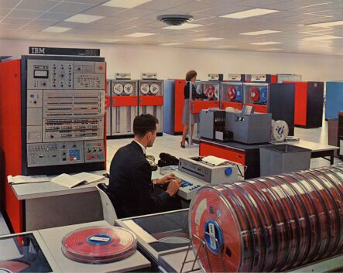
System 360 Model 50 Like the one at Sears.
=========================================================================

