Story by John Van Gardner
More - http://ed-thelen.org/comp-hist/storiesVanGardner.html

Six Weeks in Kingston, NY
Or
Where did I go wrong?

I spent most of July and August 1969 in Kingston, NY going to a six weeks school on the 360/65 System. The school was so long because it was for non 360 trained people. I had been working on the 360/50 for five years but this was the only school available. Pat Cummings was the Instructor and as usual he did an outstanding job. He and John McManee were the two best Instructors I ever had with IBM.

There were three Specialists in the class including myself. One of the others was Will Wagner who had been in my 1401 class. Pat put us in the same lab group as he did not want us to lead the other students. When the class was over there was supposed to be a week of bug shooting. We shot all the required bugs the first day. Pat said that if we were not staying for the 2870 Multiplexer school he would have let us go home. To give us something to do he let us go over to the production line and let us shoot the real bugs off those machines. The plant was not running a night shift at that time.

The first night we found a system that had just been cabled up and shot all the bugs off it that night. We had recorded everything we had done and left a note to the day shift that the machine was ready to ship.

The next day we were told not to ever do that again. We were upsetting the normal manufacturing schedule. The next three nights we would shoot one bug off a system and move to another. After the 2870 school we shot all the required bugs and went home early.

This was during the time (July 20, 1969) Neil Armstrong landed on the moon. I was in a motel room by myself (My roommate was from NYC and had gone home for the weekend) and stayed up all night watching the TV. Someone in IBM was pretty smart as they closed the plant and school the next day. There would probably been lots of industrial accidents from half awake people if they had not closed.

Years later, in 1977, I met Neil Armstrong at an awards conference in Miami, FL. I told him that I saw a picture of him in Life magazine when he was a young boy holding a Baby Shark model airplane. I had built the same airplane at the same age. The night he landed on the moon we were both in the two most desolate places in the universe. He was on the moon and I was in a motel in Kingston, NY. I asked him “Where did I go wrong?”

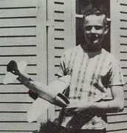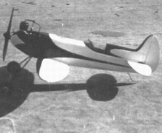
Neil’s Baby Shark My Baby Shark

