Story by John Van Gardner
More - http://ed-thelen.org/comp-hist/storiesVanGardner.html

System 370 Model 155.

June 1970 IBM announced the System 370 models 155 and 165. The IBM Sales team asked me to study up on the System 370 RAS (Reliability-Availability-Serviceability) features and give a presentation to Lockheed during the proposal. This went so well I was asked to repeat it for the Lockheed people that were not able to attend the first one.

Lockheed ordered one of each and with their defense priority they were assured of getting one of the early systems. The first Customer shipment for the 155 was scheduled for January 1971 and April 1971 for the 165. We need to get someone trained on each system as soon as possible. There were two versions of training on each model. One was the short product training school and the other was the longer support training school. The product training school was a prerequisite for the support school. Phil Henry and I were selected to go and we were allowed decide who went to which school. Both of us would go to the product school for both machines then I would go to the support school for one machine and Phil would go the support school for the other. Phil wanted to get it over with as soon as possible and I wanted to delay mine as long as possible. My reasoning was a later school is usually better than and early one and there was always a chance of someone changing their mind.

After Phil was trained there was a big defense cutback and Lockheed canceled both machines. Little did I know that this would be the beginning of my disassociation with Lockheed. Phil was transferred to a C & S Bank in downtown Atlanta because they were getting a 155. First National Bank also got a 155. I still worked out of Lockheed but went more and more into Atlanta to Assist. In January 1972 I was sent to Washington, DC for product training on the 155.

On Sunday the 9th my 8 year old son Joel came home from Sunday School with a high fever, vomiting and diarrhea. My 12 year old son Jeff had a sore throat and fever. This all the day before I am to leave for almost three weeks. The next day when I am supposed to go to the airport its pouring rain and there is a tornado warning. I took a taxi to the airport instead of having my wife drive me. My wife always handled these situations and all I had to do was work. I could have never done it without her.

When I arrived in Washington IBM had made reservations at the Gramercy Inn. It was a very nice place and I had a room with a large picture window that overlooked the swimming pool. This was January and freezing cold so I never saw anyone even walk around that pool.

The Education Manager spoke at our class opening and told us we were entering a new era. Their objective was not to teach us how the machine worked but how to fix it. The rumor going around was that someone in engineering found out what Field Engineering’s budget for education was. They said they could design a machine that could fix itself for half that money. Someone apparently believed that and didn’t wait for a machine that could prove that.

The 155 was designed by the group of Engineers that had designed the 360/50. I knew how everything in the model 50 worked but the only knowledge that would transfer to the 155 was in the core storage area. Everything else was different. The 155 used MST technology that was about four times as dense as the SLT used in the 360/50. The machines were about the same physical size. Even allowing for the fact that power supplies never shrunk as much as the chips there was a lot more circuitry in the155.

The maintenance plan for the 155 was the product trained CE would take the service call and run all the FLT and Scan test and they would detect the failure and call out the bad card. The product CE would replace this card and fix the machine. If this did not fix the machine the product CE would call for assistance from a Support trained CE. The Support CE would use his superior training and knowledge to trouble shoot the trouble like on past machines.

The FLT and Scan test used a new device in the system called the floppy disk. The tests were located on a series of 8” floppy disk and when they detected a failure they displayed a number on the console. You looked this number up in a chart and it told you what card to change. The first thing I noticed was there were gaps in the numbers. I wondered how long it would be before I worked on a machine that gave me one of these missing numbers.

The 155 was a totally microcode controlled machine, CPU and Channels. The school did not touch on the micro orders or how to read the code. They said that was not our job. I took a look at the documentation and could not make heads or tails of it. It was represented completely different from the 360/50.

The biggest joke of all was the 2955 FE Data Access Unit. This was a 2701 Transmission Control Unit with a TA-1 adapter to connect to a dialup modem. It was supposed to give Poughkeepsie access to a machine to help diagnose a problem. The only trouble was it was attached to a channel which required the Channel, CPU, Memory and Power to be working to communicate. If all this was working you didn’t have a problem. The only use it ever served was as a place to lay your books while studying a problem. Later on we called it an “Electric Table”.

All the lab bugs were based on the maintenance plan. You ran the tests. It called the bad card. All this was to convince you it would work. I knew it would work sometime and maybe most of the time. It was the other times that worried me.

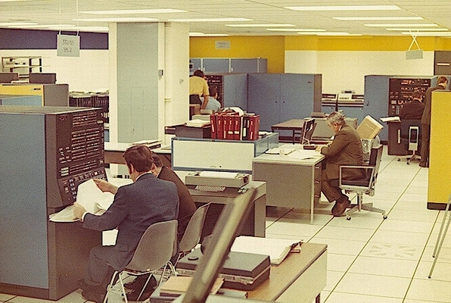
3155 Lab At Washington, DC Ed. Center.

When the school was over we had to fill out an evaluation form for the school. I wrote in the comment section the following: “The first day of school you told us your objective was not to teach us how the machine worked”. “You have met your objective”.

After I returned home and went back to work the Branch FE Manager asked me, “How was the school”? I told him I thought he should send every Field manager to that school and have them take the first 155 call that came in after they got back. I didn’t expect any of them to be able to fix it but at least they would understand the utter helplessness a CE would feel in the same situation. He shook his head and said, “That bad huh”? The sad thing about it was I had just spent about the same amount of time in this school as I had in 7090 school and they taught me how it worked. My only hope now was to get into a support school.

