Story by John Van Gardner
More - http://ed-thelen.org/comp-hist/storiesVanGardner.html

The 2321 Data Cell & Joe Rufin

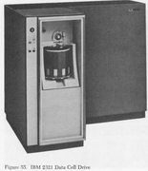
IBM called the 2321 a Data Cell but everyone else referred to it as a Noodle Picker, Noodle Plucker or many other unprintable names. One CE said, “A device that Rube Goldberg would have declared to be far too complex". It was the only machine I knew of that Field Engineering Technical Operations and the Product Test group did a “Non-Concur” on because of reliability and serviceability. That meant they would not approve of releasing the machine to the field.

It is also the only machine I know of that had an Engineering Change to replace the casters. I don’t know the story of why this was done but I still have the casters removed from the machine at Lockheed in my barn now. I used to hear CE’s say they had replace everything on a machine but the casters and it still didn’t work. Then I would tell them about the 2321 EC.

The machine had three major sections in the mechanical part that handled strips. First there was what was called the Drive. I would have called it the storage bin as that’s where the 10 pie shaped Cells were mounted to form a circle. Each Cell was divided into 20 Subcells. Each Subcell held 10 magnetic recording Strips. This meant there were 2000 Strips in the drive. Each track on a Strip could be 2000 bytes long so the total capacity of the 2321 was 400,000,000 bytes. The Drive was rotated under a Selector Station by a Vickers hydraulic motor. The hydraulic pump that supplied the oil to the hydraulic motor was driven by a 5 HP electric motor. This was a small version of the system used on battleships to move the 16” gun turrets. I knew my navy fire control training would come into play one day. That Drive really moved when the circuits told it to. I was very careful around that Drive, as I knew what it could do. The front door of the 2321 had laminated safety glass and an electric lock on the inside of the door. I had heard the story of the 2321 being run in the plant without the door. A Cell came loose from the Drive and was thrown across the plant busting a hole in the concrete block wall.

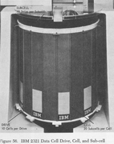

The second mechanical section of the machine was what selected which Strip would be pulled from the Subcell. This was done by four little piano wire Fingers that rotated down and came in contact with two 1/16” tabs on top of the Strips on both sides of the Strip you actually wanted to pick. If you wanted to pick the # 5 Strip one set of Fingers would contact the tabs on the # 4 Strip and the other set of Fingers would contact the tabs on the # 6 Strip. As the Fingers rotated further down they would pull all the other Strips away from the # 5 Strip leaving it sticking up by itself. The Finger assembly moved fore and aft in front of the tabs before rotating to select the proper Strip.

The third mechanical section of the machine was the Drum. The Drum rotated in a precision highly polished cavity. Attached to the Drum was a Picker Head. The Drum could rotate in either direction. When you wanted to pick a Strip it would rotate counter-clockwise and the Picker Head would go down a chute until a small spring loaded latch came in contact with the selected Strip. The Strip had a 5/16” square hole near the top center of the Strip. The Picker Head latch would lock onto this hole and when the Drum reversed direction it would pull the Strip out of the Subcell and rotate it around and around the Read/Write Head. The acceleration was so fast the data could be read from the Strip on the first pass over the R/W Head. The R/W Head had 20 tracks with separate Write and Read head segments. The whole R/W Head assembly could move fore and aft to 5 different positions allowing 100 tracks to be recorded and read on each Strip. When finished reading or writing the Drum reversed to put the Strip back in the Subcell. This was the tricky part. How do you push a rope? As the end of the Strip came out of the Drum cavity small jets of air were injected in both sides of the Strip down into the Subcell. This carried the limp end of the Strip into the Subcell. The latch on the Picker Head was released from the hole in the Strip and the Drum rotated clockwise to bring the Picker Head back up into the Drum cavity. Now you could go after another strip.

The original design of the machine had no way to get to the Fingers except to start removing all the parts on top of them. This would not have made it in the field. It was redesigned so that the Drum assembly would fold up out of the way as a unit.

The biggest problem with the machine was that there was no mechanical connection with the three sections. They were synchronized by electronic circuits using individual miniature light bulbs and photo cells. If you lost a light bulb the machine could lower the Picker Head through the Fingers before they were rotated out of the way. There were many catastrophic combinations like this. The bulbs didn’t have a good lifetime and were vibration sensitive. This machine had a lot of vibration. Engineering finally released a change where all the individual bulbs were removed and fiber optic tubes were run to a single large bulb. It was an automobile tail light bulb. This greatly improved the reliability of the machine.

When the System 360 was announced Lockheed ordered a Model 65 with a 7080 emulator feature to replace their real 7080. The 7080 had always run in batch mode where the input tapes were prepared by 1401 Systems. The 7080 program card decks would be written on tape one after the other to be read into the 7080. After they got their Model 65 they ordered a 2321 Data Cell. Pat Pattillo and I went to school together in Poughkeepsie. My old 704 classmate Bob Bartlett from Ft. Walton, FL was in the same class. We got to stay in the Poughkeepsie Inn as the Marketing people it was usually reserved for had moved on to a newer motel I still remember the big blackboard in school with the “Seven Nevers” written on it. These were rules that if you broke one you would destroy the machine. Pat and I broke the one that said “Never crank the Picker Head through the Fingers. Most lab groups broke more than one while there.

Lockheed put all their 7080 programs on the 2321 and could make an input tape for the 7080 emulator by reading the programs from the 2321. It was random access and you could go directly to the program you wanted.

Things went smoothly for a while then we ran into a problem. IBM had advertised that you could pick a Strip 12,000 times before it wore out the oxide. No one ever thought they would run the same 7080 program 12,000 times and they didn’t. What had been overlooked was the fact that every time you requested any data from the 2321 the operating system went to Strip 0 to read the VTOC (Volume Table of Contents) to see where that data was written. Strip 0 was wearing out and when it goes you don’t know where any of the data is.

The only thing that saved us during this time was the Utility program Jim Moss had written named “SuperDog”. Jim’s program could copy anything and write it anywhere you told it to. He did a lot of VTOC reconstructions. Later on when the 2314 came out and Lockheed got one someone came up with the idea to put the VTOC for the 2321 on the 2314 and this solved the problem.

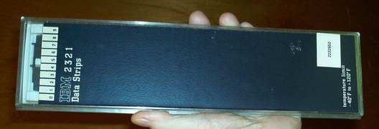
The Strips Came 10 To A Box Like This

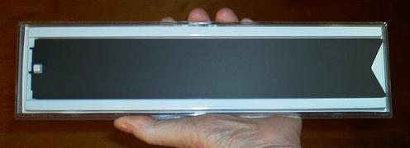
There Is Only 1 Strip In This Box. Note Tabs And Hole On The Left End.

One day I received a call to go assist Phil Henry on a 2314 at the State of Georgia Revenue Department in Atlanta. It had been down for a long time and when I got there I was introduced to Joe Rufin. Joe was our new Branch Office FE Manager by a few days and I had not met him before.

Phil told me the 2321 control unit had a bug on it and he could not get a handle on it. The scope he was using was in bad shape and I could not see some of the fain traces so I asked if they had another scope. Someone brought me a Tektronix 453 and when I put it on top of the control unit one of the toggle latches on the top cover turned loose. The cover fell off the scope and hit me in the chest and bounced into the top SLT panel next to the CE panel. It bent a bunch of pins and the machine immediately powered off. I thought, “What a great introduction to the new Branch FE Manager”.

I straightened all the bent pins I could see making sure I did not pull any of the wires too tight around a via pin. Then I powered the machine up and it came up working. The bug was gone and the customer wanted the machine back.

I turned around to Joe and said, “Now you know why I’m the Specialist”. He just turned and walked away.
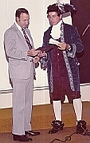
Van & Joe Rufin

His Mama Dressed Him Funny

