Story by John Van Gardner
More - http://ed-thelen.org/comp-hist/storiesVanGardner.html

What’s a Snake Killer award?

In November 1972 a new MADAR 360/65 was installed at Tinker Air Force base in Oklahoma City, OK and when it became operational the one at Lockheed would be discontinued. Some of the Lockheed operators went to Tinker to train the Air Force operators. After about a month I got a phone call from the local FE Specialist at Tinker telling me a problem he was having with the Lockheed operators. It seems they were getting a lot of “Intervention required” error messages on the phone lines to the IBM 1130 computers at the C-5 bases. The operators kept telling everyone they had never seen one of these messages on the system at Lockheed. They remembered a lot of “Time Out” messages but no “Intervention required”. I suspected the telephone company modem options were strapped differently. I ask the Specialist to go check his modems and write the options on a piece of paper and I would do the same at Lockheed.

It turned out the modems at Lockheed had the “Data Set Ready” strapped active all the time. The modems at Tinker were strapped “Data Set Ready” under control of the modem. The intervention required message comes from the loss of Data Set Ready. Data Set Ready is dropped inactive when it looses sync with the modem on the other end of the phone line. When there was a phone line problem on a Lockheed line you could not get the Intervention Required message because the Data Set Ready line was always active. What you did get was a Time Out message because the remote computer could not respond to your poll due to phone line trouble. When the same condition occurred on a phone line to Tinker they got an Intervention Required error message. When I explained the situation to the people at Tinker I could hear a lot of shouting and cheering in the background. This whole process took less than an hour over the phone and I forgot about it.

About a week later I received a cardboard box that looked like some parts but when I opened it I was really surprised. Inside was a tall coffee mug with a picture of an old cowboy popping the head off a snake like a whip and stomping two others with his boots and spurs. Under it was printed, “SNAKE KILLER”. Included was a letter that said:

We in the Oklahoma City DP and FE branch offices would like to express our appreciation for the assistance you provided on the night of November 29 at Lockheed. We had spent many hours trying to duplicate Lockheed’s MADARS communication system at Tinker Air Force Base in Oklahoma City. The information you provided has saved us many additional hours of frustration.
We are enclosing our “Snake Killer” award as a token of our appreciation for your help. Thanks again for killing a big snake for us.

Signed by the FE Specialist, FE Branch Manager, Senior Systems Engineer and the Staff Program Support Representative.

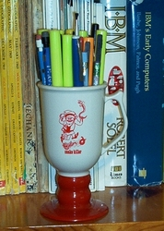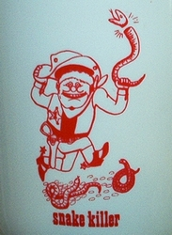
I have received many awards from IBM. None are more treasured than this one. It holds the pencils on my desk and I look at it every day.
=========================================================================

